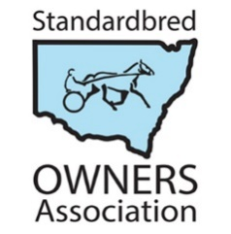
NSW Standardbred Owners Association

MEMBERSHIP APPLICATION / RENEWAL 2024 SEASON
(1 January 2024 to 31 December 2024)
ANNUAL MEMBERSHIP FEE: $60.00
I hereby apply for membership of the NSW Standardbred Owners Association (NSWSOA) and agree to be bound by the Rules of that Association.
Name:

Address:

Suburb: |  | Postcode:
Mobile: |  | Telephone:
Email:

Signature: |  | Date:

PAYMENT OPTIONS
1. | CHEQUE / MONEY ORDER | Please make payable to: NSW Standardbred Owners Association  Post to: P O Box 7, OURIMBAH NSW 2258
2. | PAYPAL /  CREDIT/DEBIT CARD | Payment can be made via PayPal (through our website).  Go to: www.nswsoa.com.au/join now, then scroll down to the PayPal button and click on “Add to Cart” to process your payment.  Please note: PayPal payments attract a $2.00 admin fee ($57 will be deducted from your account)
3. | DIRECT DEPOSIT | Account Name: NSW Standardbred Owners Association Inc  Bank: ANZ Castle Hill  BSB: 012-263  Account Number: 2814 354 21

